**Sql Test2 31061 32606 Spr 20**

**Student no:** 13815372

**Student Name:** Pengyu Zhang

**Question 1.**A “GROUP BY”, which may require WHERE and HAVING conditions.

List all years in which the shuttle flew only one mission.

 launchyear | Missions ß name of second column optional

------------+---------

       2003 |     1

       2005 |     1

(2 rows)

select launchyear, count(missionno) as "Missions β" from Nasa2_mission where projectname = 'Shuttle' group by launchyear having count(missionno) = 1 order by launchyear;

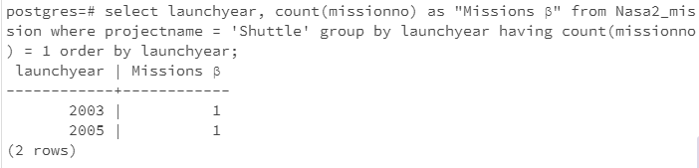

**Question 2.**A simple sub-query

 craftname | missionno | launchyear

-----------+-----------+------------

 Endeavour | STS-47    |       1992

select craftname, missionno, launchyear from Nasa2_mission natural join Nasa2_spacecraft where projectname='Shuttle' and craftname = 'Endeavour' and launchyear = (select min(launchyear) from Nasa2_mission natural join Nasa2_spacecraft where craftname = 'Endeavour' and projectname='Shuttle');

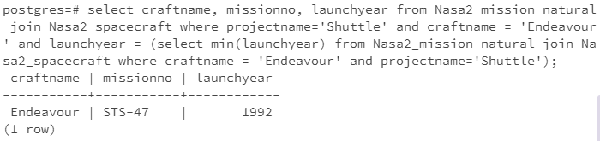

**Question 3.**A join requiring the cross product notation

Order by the astronaut name, and the Apollo mission number.

Hint : Nasa assigned may be used twice, like Nasa2_assigned as N1 and Nasa2_assigned as n2

         astroname         | apollo | shuttle

---------------------------+--------+---------

 Mattingly, Thomas         | 16     | STS-4

 Mattingly, Thomas         | 16     | STS-51C

 Young, John               | 10     | STS-1

 Young, John               | 10     | STS-9

 Young, John               | 16     | STS-1

 Young, John               | 16     | STS-9

(6 rows)

**select astroname, a1.missionno as apollo, a2.missionno as shuttle from Nasa2_astronaut, Nasa2_assigned a1, Nasa2_assigned a2 where Nasa2_astronaut.astrono = a1.astrono and a1.astrono = a2.astrono and a1.projectname = 'Apollo' and a2.projectname = 'Shuttle' order by astroname, apollo;**

